

Name: **LOW JUN LING**

Login ID: **lowjunling@oasis-portal.com**

Course title: **Accounting Fundamentals**

Subject Code: **BHM03**

Submitted date: 07/08/2017

**Table of Contents**

|  |  |  |
| --- | --- | --- |
| No | Details | Page |
| 1 | Executive Summary | 2 |
| 2 | Introduction | 3 |
| 3 | Assignment Question |  |
|  | Part 1 | 4-5 |
|  | Part 2 | 6-7 |
|  | Part 3 | 8-9 |
|  | Part 4 | 10-12 |
| 4 | Conclusion | 13 |
| 5 | References | 14 |

**Executive Summary**

In this assignment, I understand of Accounting Fundamentals and its application in business. First of all, I talking about the introduction in Accounting basics. In the introduction, tells about the accounting operation and what is income and expenses ? In first question, I will explain the topics about define on the role of accounting and the entire process of accounting. In second question, I understand the income and expenses coupled with differences between accounts payable and accounts receivable. For third part, I will describe in accounting why does the company profit appears as credit in balance sheet. Finally, I studied about what is meant by reconciling an account and computerized accounting system.

.

**Introduction**

Accounting is based on the study of financial activities and cost data collection, classification, synthesis, analysis and interpretation based on the formation of information systems to assist decision-making to effectively manage the economy of an applied discipline, it can be said that it is an integral part of social science, Is also an important management discipline. The study of accounting is like a movement of money. Accounting basis refers to the basic accounting matters, financial transaction process analysis reporting, recording, classification summarizing. Accounting is the standard way to confirm the company's operating income and cost standards. The company's performance and financial performance will be directly affected, whether it is income or expenditure in different periods of the proportion. There are also some basic accounting terms, including assets, liabilities, income statement, balance sheet and cash flow statement, as well as accounting and accounting. Accounting is essentially the amount of the balance sheet item at the time of preparation of the financial statements, in particular the identification of appropriate concepts applicable to the transaction, the determination of the purpose and the proceeds and expenses of the project to ensure that the Company's profits show an understanding of the Company's profitability. Accounting is a system that records the financial transactions of a business.

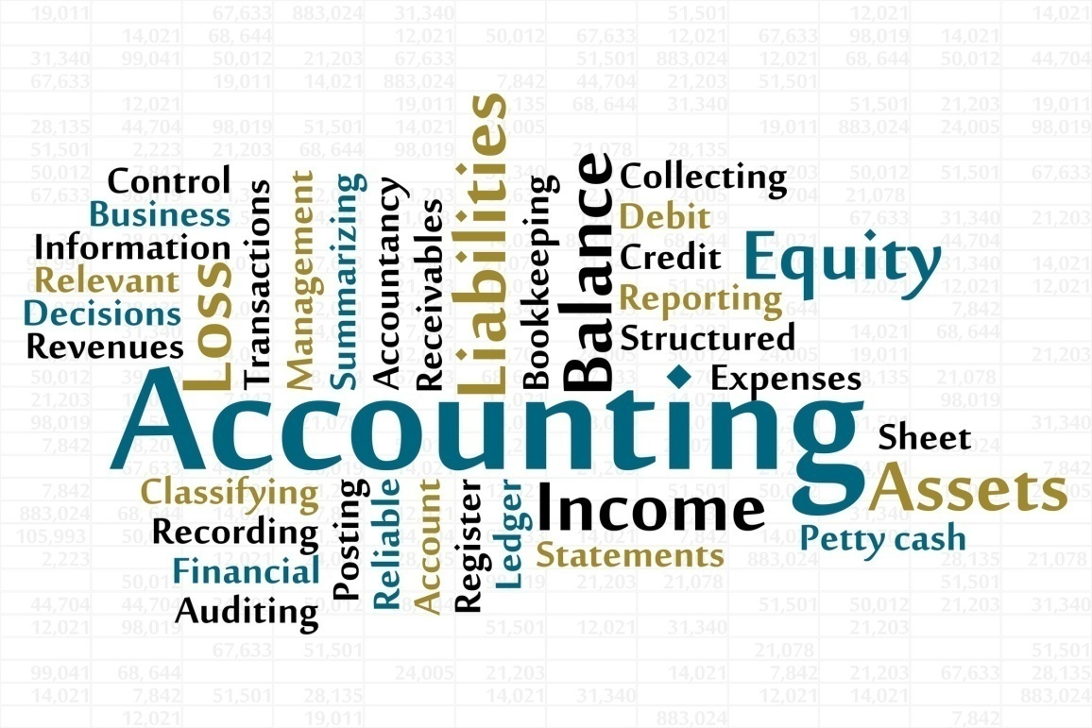

***Figure 1: 28 Accounting cliparts***

**Assignment Questions**

**Question 1**

In a brief but comprehensive response, define the role of accounting.

Accounting principles is to measure, disclose or provide information on the guarantee to help managers and other decision makers to make resource allocation decisions. Financial accounting is a branch of accounting, history has been involved in the business by the financial information is identification, recording, measurement, classification, validation, aggregation, interpretation. The objective of the accounting is to ensure that the financial report is useful to the manager, the firm (the regulator) and the stakeholders (stakeholders) such as shareholders (or shareholders), creditors (creditors), or business owners. The preservation of the daily record of participation in this process is also known as book-keeping. In 1494, Venice published a book in the book, De Computinget Scripturies, in this book there is a short "book-keeping", the author of this book is a mathematician, **Luca Pacioli** , he is the father of accounting, He is the person who creates the principle of a Double entry system based on modern accounting. Accounting start with the double entry system. Double entry system is an important factor in modern financial accounting. The system consists of at least two entries inserted into each transaction during the course of business, an debit account, and credit notes, while the debit notes in one account to another. All debits should always be equal to the sum of all credits. This is a billing system, each account needs the corresponding and the opposite entry into a different account. [Assets = Liabilities + Equity] is a double entry is the basic concept of modern bookkeeping and accounting. In the double entry system, all transactions are recorded by debit and credit. Since the debit of an account is offset by the credit in another account in the book, the sum of all debits will be equal to the sum of all credits. From which we can through the dual system to see the exact preparation of books can also detect the wrong financial statements. There are several different types of accounts in business transactions, with assets, liabilities, stocks, income, expenses, losses, benefits. In the bookkeeping, the amount of each change, are related to the company's business activities. The role of accounting is like a system that provides information, often referred to as a "business language", because it provides a lot of information needed to assess the company's financial performance to the owners, managers and investors. In addition to investment, stakeholders also receive information on financing and operations. Accounting includes measuring and summarizing business activities, explaining financial information, and summarizing it will be communicated to management. Accountants communicate financial information to help them use financial information to deal with business issues. If there is no accounting, some companies can't run their financial information in a timely manner. Financial accounting helps them assess the company's financial performance to help them run better business.

***Color Accounting International,(1992-2016)***

***Figure 2: The History of Accounting***

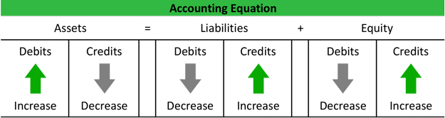 ***My Accounting Course,(2017)***

***Figure 3: Double Entry Accounting***

**Question 2**

What is the difference between accounts payable and accounts receivable?

Accounts payable and accounts receivable are business-related mobile accounts. One is that we have to receive customers, one is our response to the supplier. Accounts receivable makes our assets, because the amount of goods to be sold or served, means that the company must obtain cash, on the contrary, the accounts payable is our debt, because we took the goods with the supplier, but also No payment, this is a sum that can't be paid immediately. However, accounts payable will require us to pay these debts for a specific period of time to avoid default and to be unable to cooperate in the future. Although the accounts receivable and accounts payable procedures are the same, but in the collection procedures, will be more complex. In the case of accounts payable, the company may not have strict procedures. So in accordance with industry policy, the company's standards and financial conditions to develop. The accounts receivable are credited to the assets of the company's balance sheet. And accounts payable are recorded as liabilities on the Company's balance sheet. Accounts receivable represent the amount of the company, while the accounts payable represents the amount owed by the company entity. Accounts receivable are reflected in the future date of the customer can receive the amount owed to the company, but the accounts payable after the disclosure of the debt we will pay to the supplier. Accounts receivable will increase cash and accounts payable will be reduced.

|  |  |
| --- | --- |
| Accounts Payable | Accounts Receivable |
| A/P | A/R |
| Liabilities | Assets |
| Creditors | Debtors |
| Credit Purchases | Credit Sales |
| Expenses **(-)** | Income **(+)** |

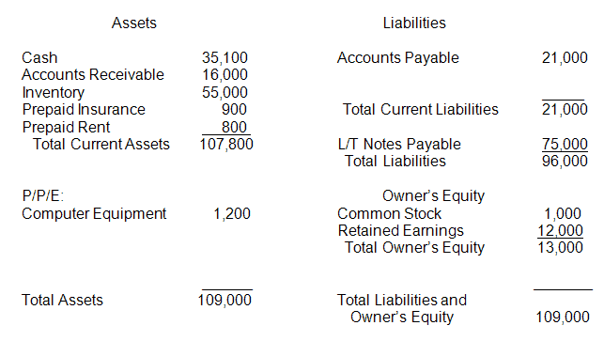

***Figure 4: Learn Financial Accounting***

**Example Ledger Accounts Receivable & Accounts Payable:**

1. Sale $ 2000 to Debtor Mr. Chong.
2. We pay cash $3000 to Creditor .
3. DR **Sale** CR DR **Mr. Chong** CR

**$2000 $2000**

1. DR **Cash** CR DR **Creditor** CR

**$3000 $3000**

The theory of accounting is the structure of the concept of accounting. Through the concept of some financial accounting standards to determine the objectives of corporate financial reporting, to understand the financial accounting rules and principles of the theory of the foundation. Accounting theory is qualitative, the practicality of basic accounting theory is to provide financial statements in the form of information to help business and economic decision-making. The financial report provides basic information about useful information about decision making, which also means that accounting theory is intentional and flexible, even when the legal environment changes and can provide effective financial information. Accounting information should be relevant and reliable information, and to ensure that all the financial statements are accurate, but also to comply with the standards of generally accepted accounting standards. In addition, the accounting theory requires that all accounting and financial personnel must act under the assumption. Assuming the operation is to help companies get better financial performance, so basically the annual or monthly preparation of the relevant financial statements. Finally, the origin and evolution of accounting theory is the principle of historical cost principle, the assets are in accordance with the historical cost of procurement. From the previous history, we can see that accounting is a discipline, because the business and the economy has been constantly changing, it must adapt to new business methods, whether new technology or reporting mechanism in the gap, can help enterprises to carry out New accounting standards.

**Question 3**

Why does a company's profit appear as a credit on its balance sheet?

The accounting balance sheet is one of the major financial statements. The balance sheet is a statement that describes the company's financial position. Through the balance sheet, we can clearly see the company's negative impact. Of course, the balance sheet also needs to provide the company's financial position at the end of the specified date. For example, the amount reported on the balance sheet as of December 31, 2014 is the company's entire transaction record for the whole year. In addition, through the balance sheet description, also see the company has something and in the specified date to be repaid to the supplier of arrears. The balance sheet is a valuable information for those who want to join the company's investors, would like to know the company's management or additional credit or with bank loans to expand the business. In addition, the accounting equation and the two-entry system also provide an explanation of why the company's profits are shown on credit balance as credit. Asset accounts usually have debit balances, liabilities and equity balances. When the company makes a cash, its assets increase the debit card, and its owner's equity increases. In the income account, but the income account is the temporary account that leads to an increase in the owner's equity. If the owner makes a cash use, the asset profit will be reduced by the credit line, and the owner's equity will be passed through the debit portion of the account. Loans may be recorded first in the sole proprietors account, which is also a temporary account, which will result in a reduction in owner's equity. In addition, the credit balance of the balance sheet owner's equity or part of the shareholders' equity reflects the loss of the investment and profit of the company owner minus the amount allocated to the owner since the beginning of the company.

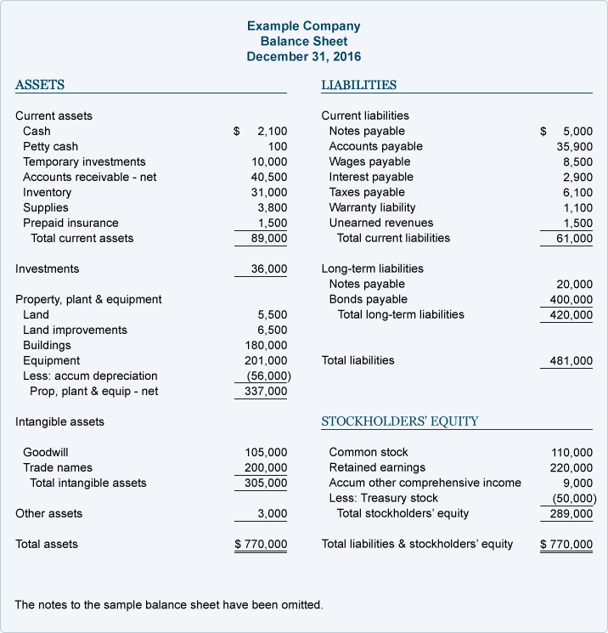

***Figure 5: Balance Sheet***

|  |
| --- |
| **Accounting Equation** |
| **（Assets） = （Liabilities） + （Shareholders' / Owners' Equity）** |

The accounting equation is the quantitative relationship between the accounting elements, which is the starting point and basis of the accounting method. When the capital is in a relatively static state, involving three important concepts, there are assets, liabilities, owner's rights and interests. The relationship between the three accounting elements at a certain point in time. How many assets a business, it must have its corresponding source. The equation is the basis for accounting, and it is the basis of the balance sheet. It shows how much of the shareholders and creditors in the assets of the enterprise. The balance of the asset is the same as the owner's equity when the liability is constant. The owner's equity remains the same, the asset changes in the same direction as the liability, and when the owner's equity and liabilities change, the change in the asset is equal to the sum of the two. Assets, liabilities, owners' equity, income, expense, and profit, there is an inherent organic link that integrates. Their comprehensive reflection is[Asset + (income - expenses) = Liability + owner 's equity + profit**]** .For example, Evergreen bought a batch of goods in cash, totaling $ 600.On the one hand, the company's inventory (assets) increased by $600,and the other hand, "cash" (assets) decreased by $600, the company's total assets didn't change, the balance didn't destroy the relationship. Every businessman in their own business most want to know is their own business losses or benefits. Accounting is a quick help to understand their own benefits for a whole year. A trading account is an account for determining the first use of a business profit or loss. Help to show the results of the sale of goods during the accounting period. The transaction account records the remaining inventory, customer returns, carriage inwards and final inventory. Through these calculations we can know the gross profit.

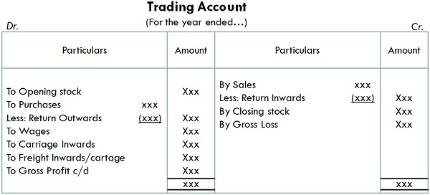

***Figure 6: Difference Between Trading Account and Profit & Loss Account***

**Question 4**

What is meant by reconciling an account?

Account reconciliation, the definition is to ensure that the company's internal accounts and bank statements to match the account reconciliation, including the relevant information included, to correct the number of accounts, no recorded invoices, check account balance, find the company accounts and Bank statements, control policies to prevent discrepancies. Account reconciliation procedures, as long as the difference can be found very simple. Accounting reconciliation when you need to correct the amount of the error, you can see them when you see the item in both documents, and you can check them by your match. Once the check is complete, it is also clear that there is no balance or some bank does not record the balance, and timely update the control account, get the final reconciliation. Simultaneously, bank reconciliation process steps is determine whether the cash account in the company has a difference from the bank statement and then tick the cash account entry with the bank statement entry, so that the cash book and bank statement is adjusted by recording. Account reconciliation is very important for internal financial control and detection fraud.

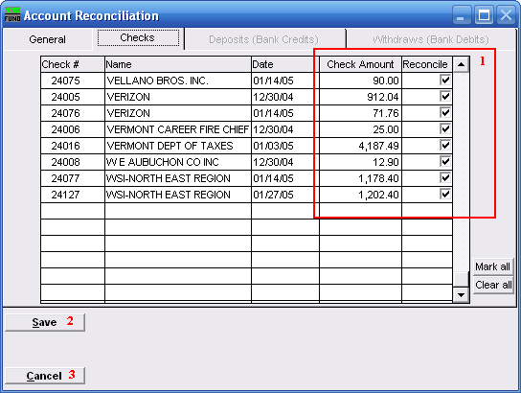

. ***Figure 7: Reconcile Account***

**Purpose &Importance**

The purpose of the account reconciliation is to ensure that the bank or the enterprise itself is missing and wrong, if a customer's check has been returned, and the check is changed, canceled, or even stolen, can also be corrected in time. The bank statement is to prevent fraud.

**Difference between the Cash Book & Bank Statement**

1. **Unaccredited item**

Sometimes the time when they are deposits at the last day of the month, the bank will automatically add to the next month.

1. **Unpresented cheques**

Some are issued by the company's check, but the supplier has not yet deposits the cheques its bank for payment.

1. **Direct debits**

Direct payment by the bank.

1. **Bank charges**

Company used, bank charges service charge

1. **Credit transfers**

Some customers transfer money directly on the online banking system.

**Format of Bank Reconciliation Statement**

1. First, you need to check the bank statement and cash book is correct, to find out no recorded items.
2. Second, update the cash book, record back to the company missing and errors items.
3. Finally, prepare a bank statement.

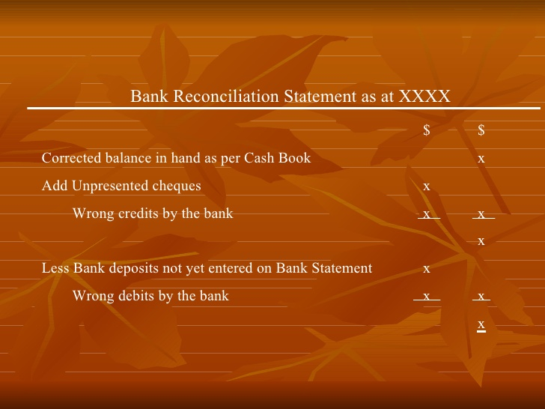

***Figure 8: Bank Reconciliation Statement***

**Conclusion**

In this assignment of Accounting Fundamentals, I learned a lot of basic accounting matters about accounting and many of the formats used to calculate. In addition, like some financial activities, the formation of information systems, income and cost standards, etc. On the first question, I understand of accounting begins with a double entry system. The double entry system is an important factor in modern financial accounting. Through the double entry system, we understand that each account needs a corresponding and opposite entry to a different account and a basic concept of accounting. I have learned that the most important accounting aspects of all organizational and personal financial conditions and values can be expressed in the accounting equation. In the second question, we can understand what is the difference accounts receivable and accounts payable. The so-called income there is expenditure. The same is true for accounts receivable and accounts payable. If there is an account receivable in our company, it is sure that the accounts payable in other companies. For each company's survival and smooth running, they are all important. While accounts receivable and accounts payable are fully managed for effective working capital management. Moreover, from the third question, it describes why does a company's profit appear as a credit on its balance sheet. The accounting balance sheet is one of the major financial statements. The company's balance sheet provides the company with the ability to compare with previous versions, providing current information to investors and corporate management. They can see how the company improved, so that investors see the company's first information. In last question, I understand of account reconciliation is important for internal financial control and fraud detection. Simultaneously, can help to correct and record back to the company lost and wrong items, also help us have enough financial control. Account reconciliation it is a good tool for bank statements.

**References**

## Color Accounting International,(1992-2016),*The History of Accounting* , RETRIVED FROM <http://www.accountingschool.org/l2_historyacc.html>

1. My Accounting Course**,(2017),** *Double Entry Accounting*, RETRIVED FROM<http://www.myaccountingcourse.com/accounting-basics/double-entry-accounting>
2. Investopedia **,(2017),** *Double Entry*, RETRIVED FROM<http://www.investopedia.com/terms/d/double-entry.asp>
3. Learn Financial Accounting , *Learn Financial Accounting*, RETRIVED FROM <http://www.learnfinancialaccounting.com/freematerial/jourent/medtestanswers.html>
4. Surbhi S **,(2015)**, *Difference Between Accounts Receivable and Accounts Payable*, RETRIVED FROM <http://keydifferences.com/difference-between-accounts-receivable-and-accounts-payable.html>
5. Difference Between.Net**,(2017)**,*Difference Between Accounts Payable and Accounts Receivable*, RETRIVED FROM <http://www.differencebetween.net/business/finance-business-2/difference-between-accounts-payable-and-accounts-receivable/>
6. Investopedia **,(2017),***Accounting Theory*, RETRIVED FROM <http://www.investopedia.com/terms/a/accounting-theory.asp>
7. John Freedman, **(2017)** , *What Are the Basic Accounting Theories?* ,RETRIVED FROM <http://smallbusiness.chron.com/basic-accounting-theories-55960.html>
8. World Arts Me, *28 Accounting cliparts* , RETRIVED FROM <http://worldartsme.com/accounting/>
9. Accounting coach, **(2004-2017),** *Why does a company's profit appear as a credit on its balance sheet?* RETRIVED FROM <https://www.accountingcoach.com/blog/profit-credit-on-balance-sheet>
10. Accounting coach, **(2004-2017),***Balance Sheet*, RETRIVED FROM <https://www.accountingcoach.com/balance-sheet/explanation/4>
11. Accounting coach, **(2004-2017),** *Accounting Equation*, RETRIVED FROM <https://www.accountingcoach.com/accounting-equation/explanation>
12. Kullabs.com, *Note on Trading Account*, RETRIVED FROM <https://www.kullabs.com/classes/subjects/units/lessons/notes/note-detail/9877>
13. Key differences, **(2017),** *Difference Between Trading Account and Profit & Loss Account*, RETRIVED FROM <http://keydifferences.com/difference-between-trading-and-profit-loss-account.html>
14. Videolar **,(2017),** *Reconcile Accounts*, RETRIVED FROM <http://videolar.co/s--reconcile-accounts--1500668414>
15. In **,(2017),** *Bank Reconciliation Statement*, RETRIVED FROM <https://www.slideshare.net/transweb/bank-reconciliation-statement-accounting>
16. Khalid Aziz**,(2012),** *Bank Reconciliation*, RETRIVED FROM <https://www.slideshare.net/khalid1173/bank-reconciliation-13157934>